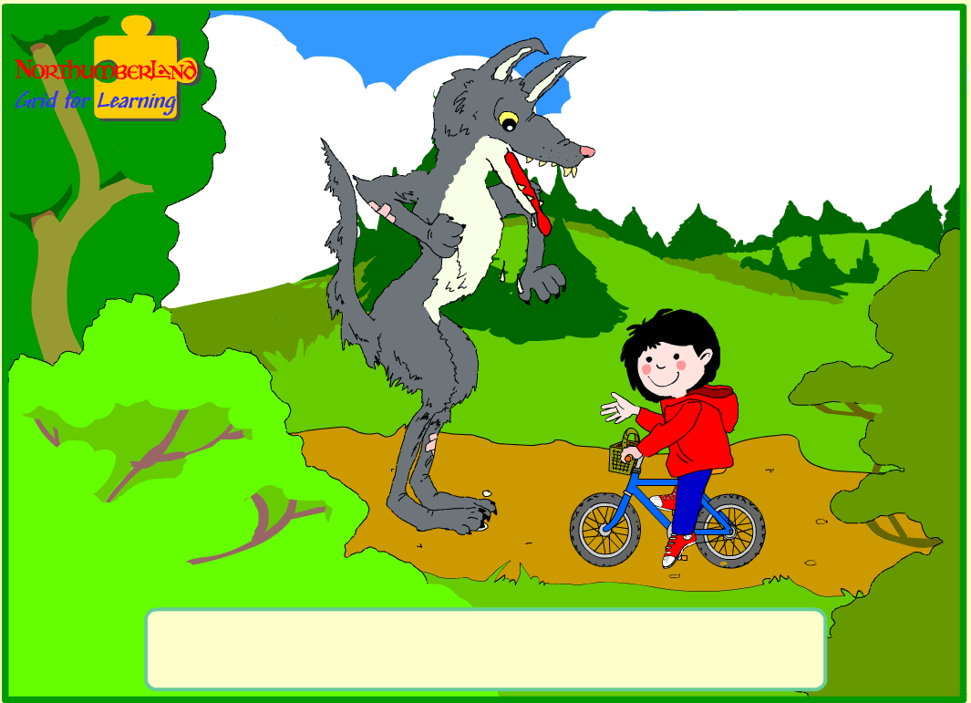
Little Red
Riding Hood

Written and illustrated by Sheila Cartwright
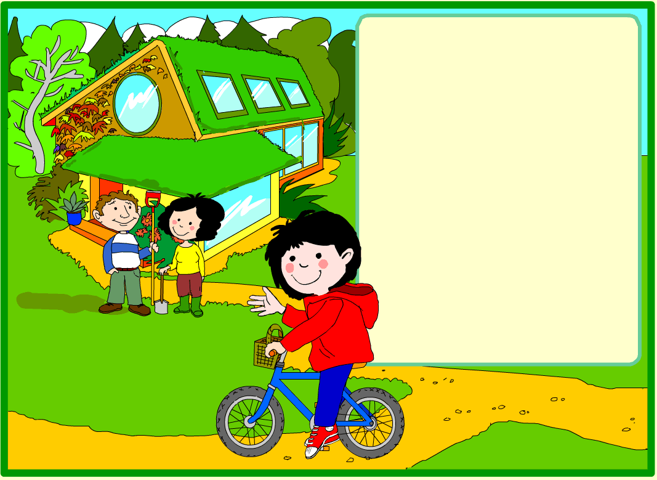

Once upon a time, there was a girl called Little Red Riding Hood.

She lived with her parents at the edge of a big forest.

Little Red liked to ride her bike all over the forest paths.

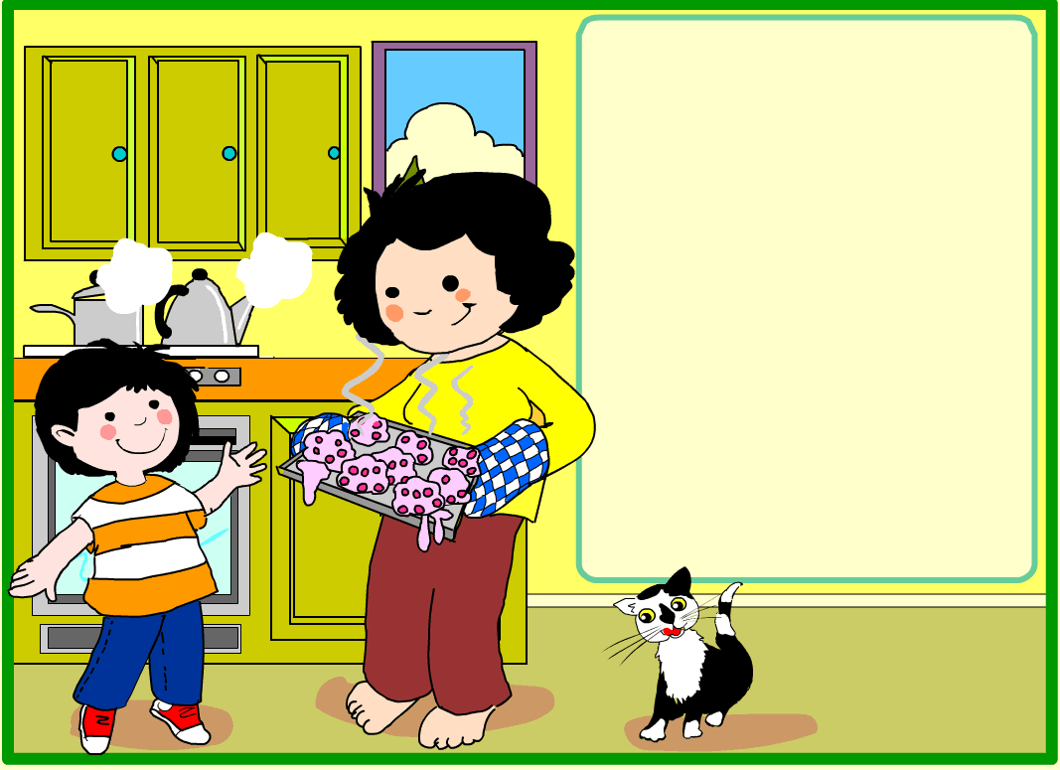
One day, her mother made some very tasty cakes.

She asked Little Red to take them to her grandmother who
lived at the other side of the forest.

Little Red said yes because she liked visiting Gran.

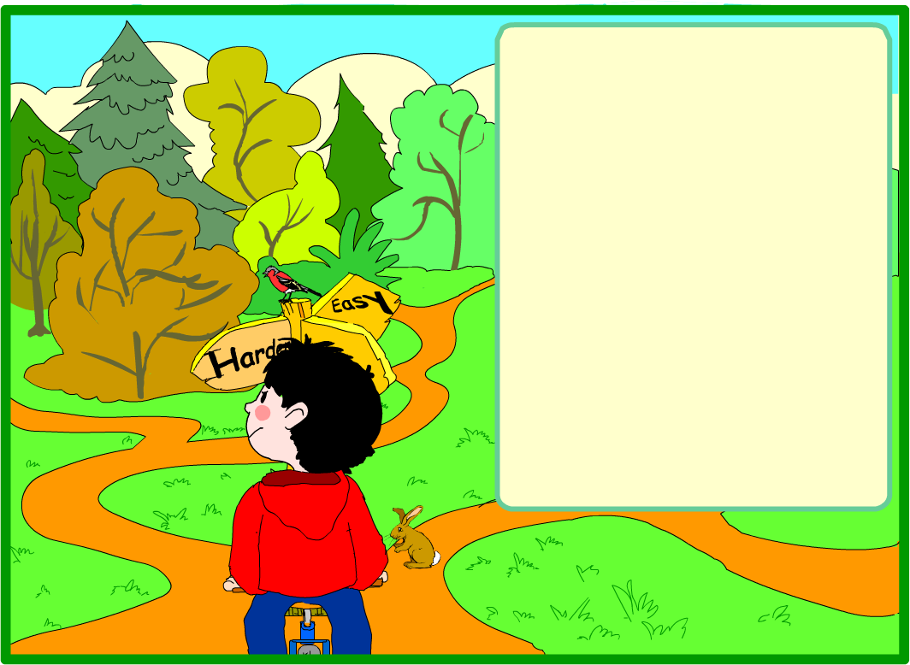
Little Red set off on her bike to ride through the forest.

There were many trails she could choose from to get to Gran's house. Some trails were made in strange shapes.

You can find the way!

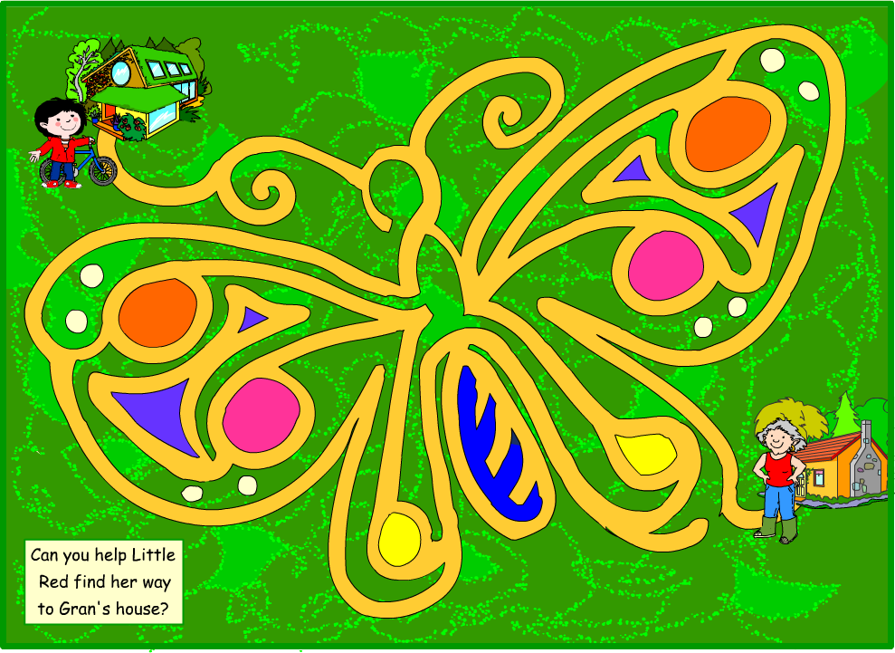

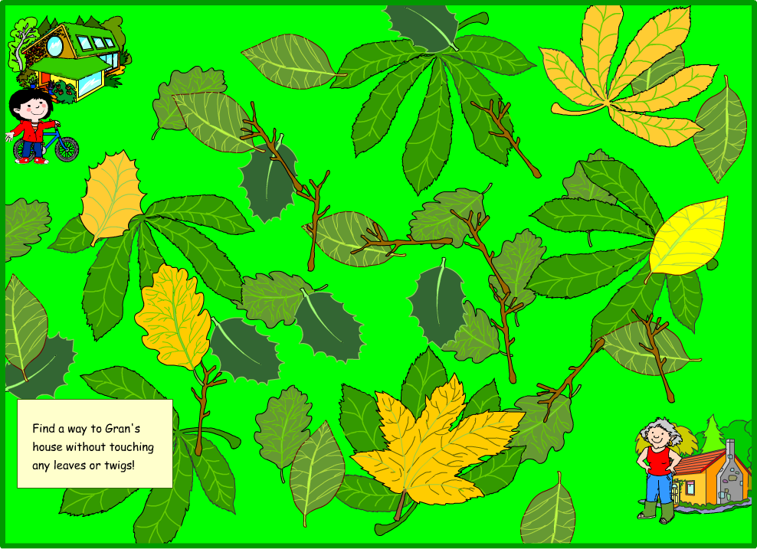

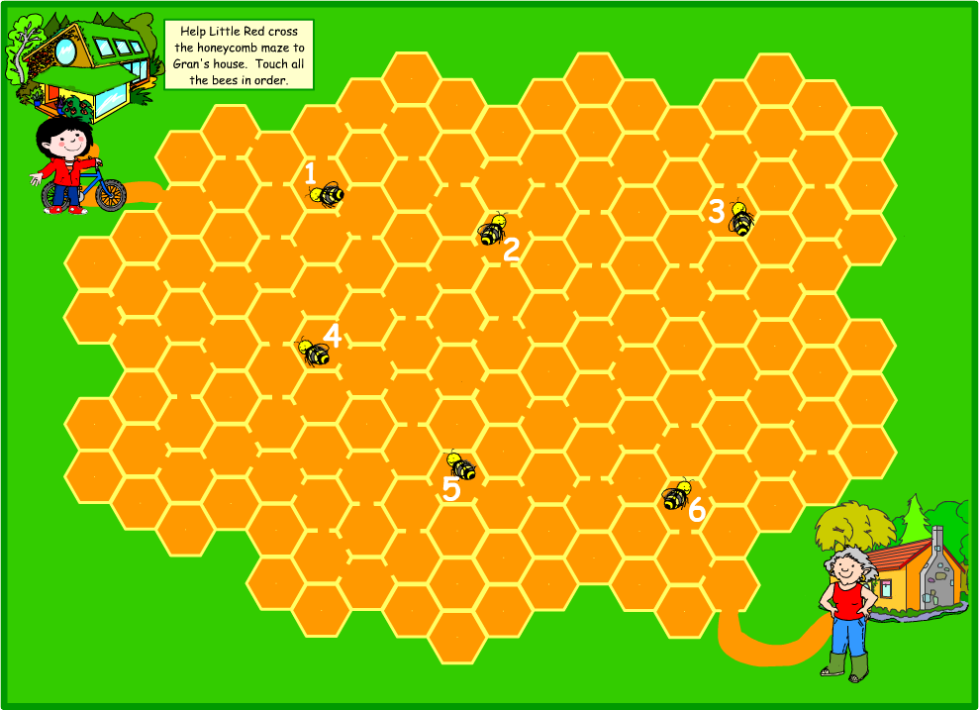

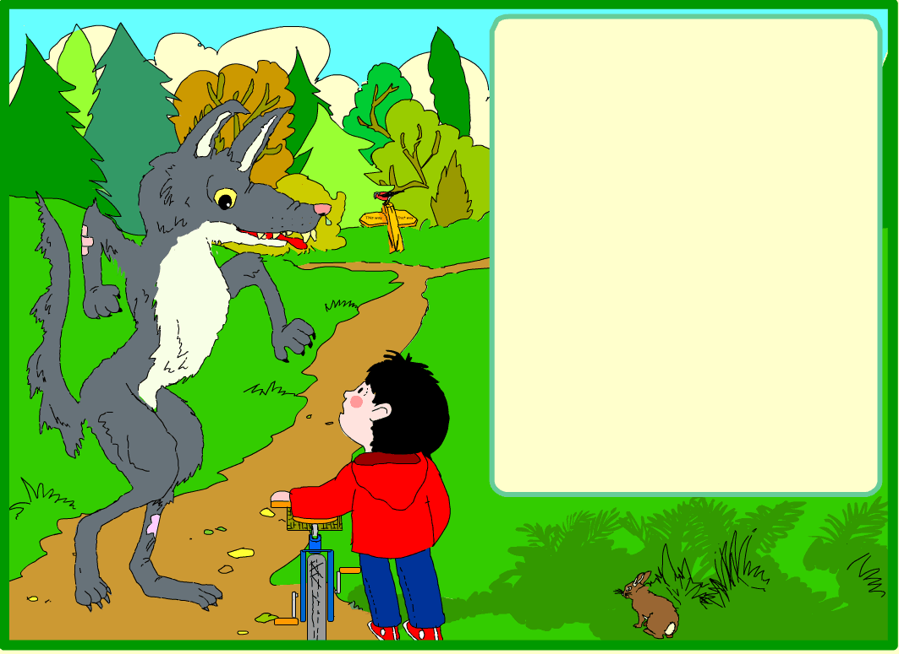
The bike got a flat tyre and Little Red had to push it.
A big wolf came along.

"Hello my dear," said the wolf. "Where are you off to this fine day?"

"I'm taking some cakes to my Gran's house on the other side of the forest," said Little Red.

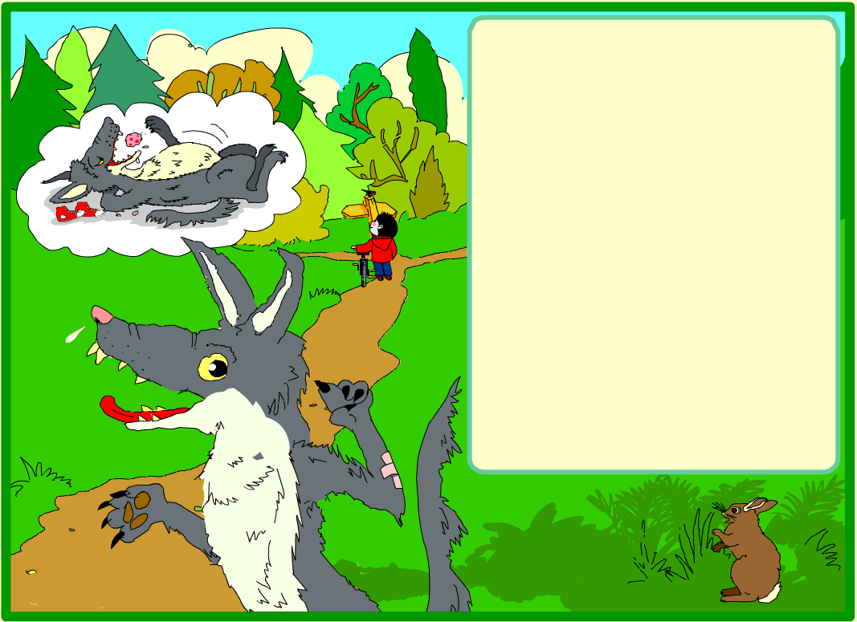
The wolf came up with a plan. He would race through the forest and get to Gran's house first.

Then he would wait for Little Red, eat her, and all the cakes too!

And no-one would see him!

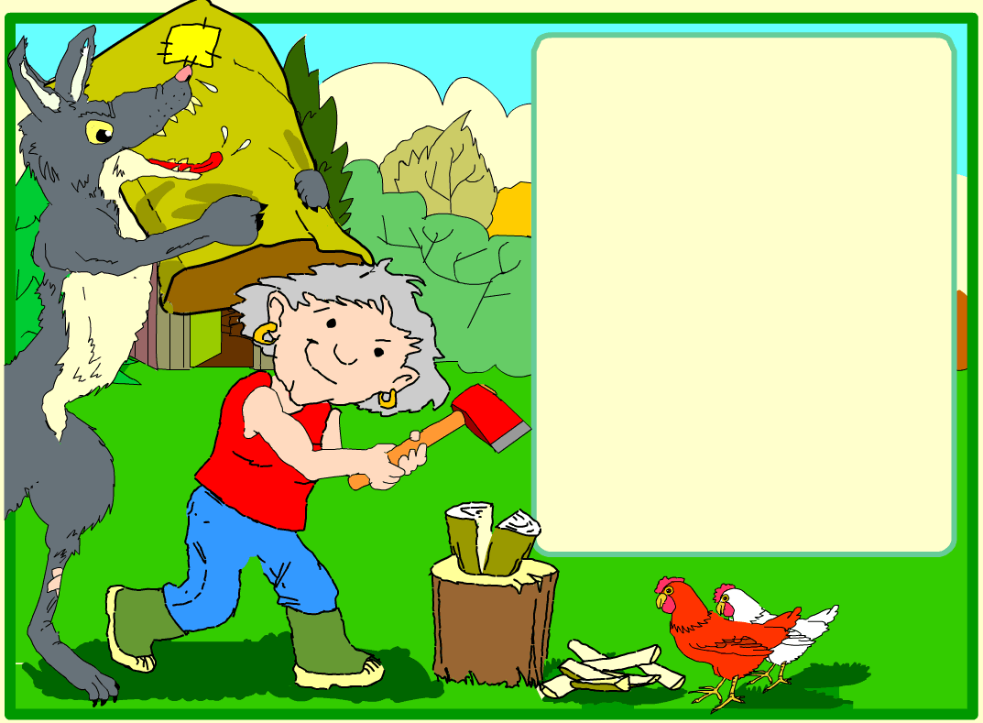

The wolf ran as fast as he could to Gran's house.

He found her cutting wood. She was far too tough to eat so he bundled her in a sack and locked her in the shed.

Then he went into the house.

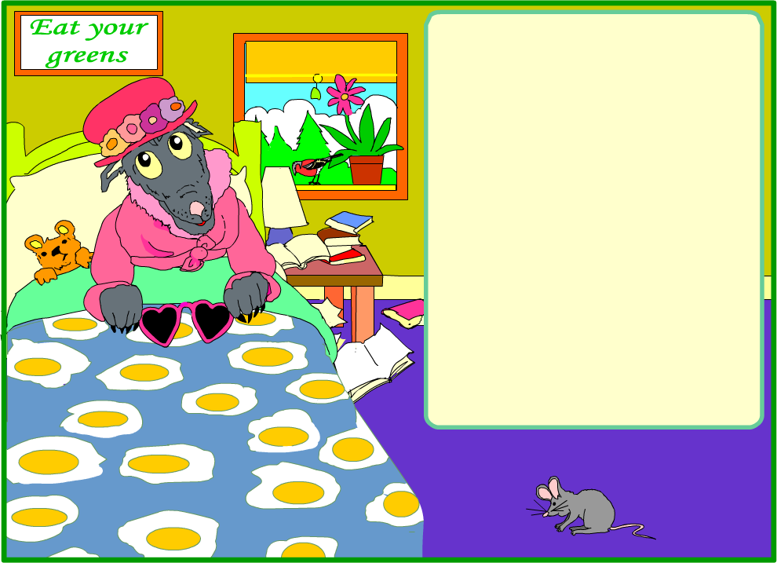

He put on Gran's clothes and got into her bed. He hoped he would fool Little Red.

He waited for Little Red to arrive, thinking how yummy it would be to eat cakes and a tasty little girl too!

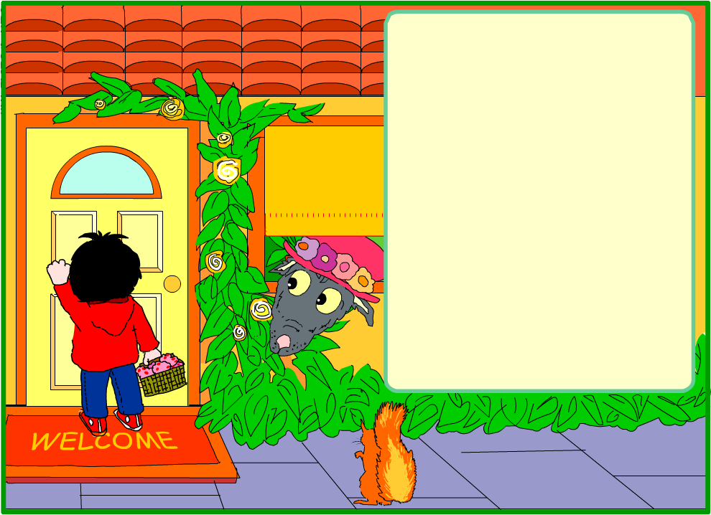

Little Red knocked on the door.

"Come in, my dear," said the wolf in a croaky voice.

Little Red said, "Gran, have you got a sore throat?" and opened the door.

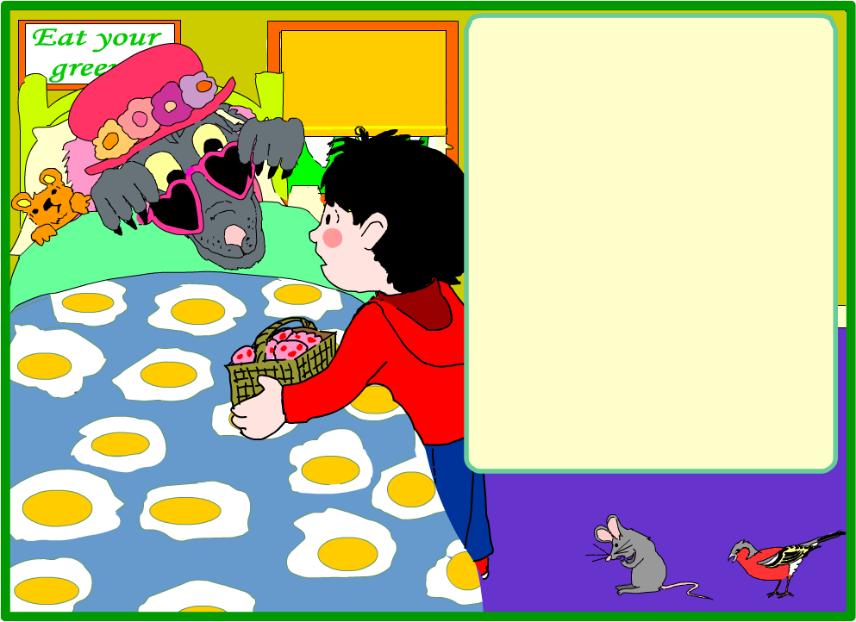
Little Red came into Gran's bedroom. She thought Gran looked very strange.

"Gran, what big eyes you have," she said.

"All the better to see you with, my dear," croaked the wolf, licking his lips.

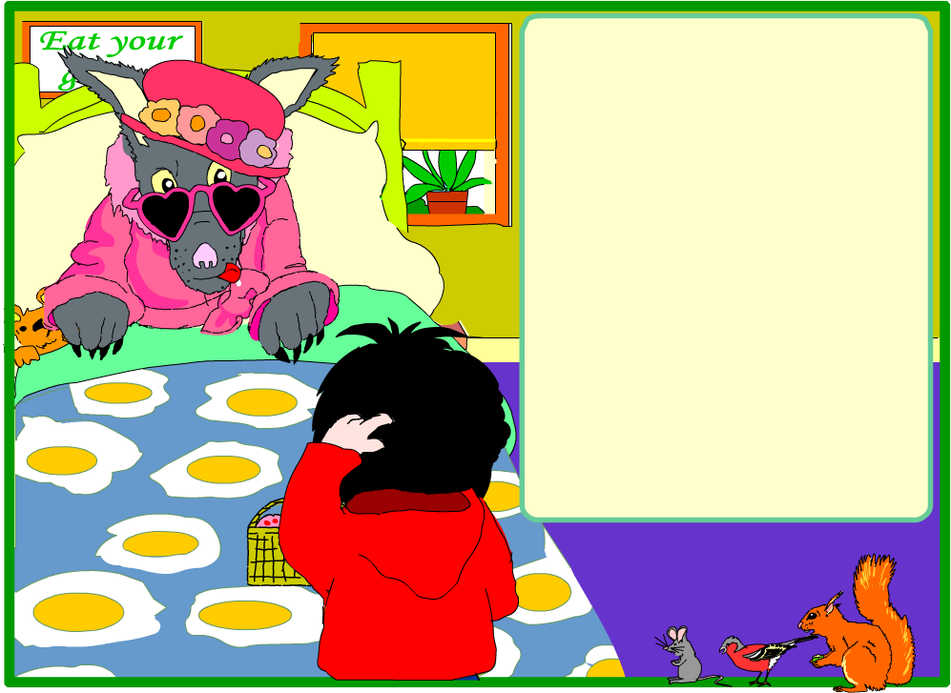
Little Red looked at the wolf’s furry ears.

"Gran, what big ears you have," she said.

"All the better to hear you with my dear," growled the wolf.

He was feeling VERY hungry.

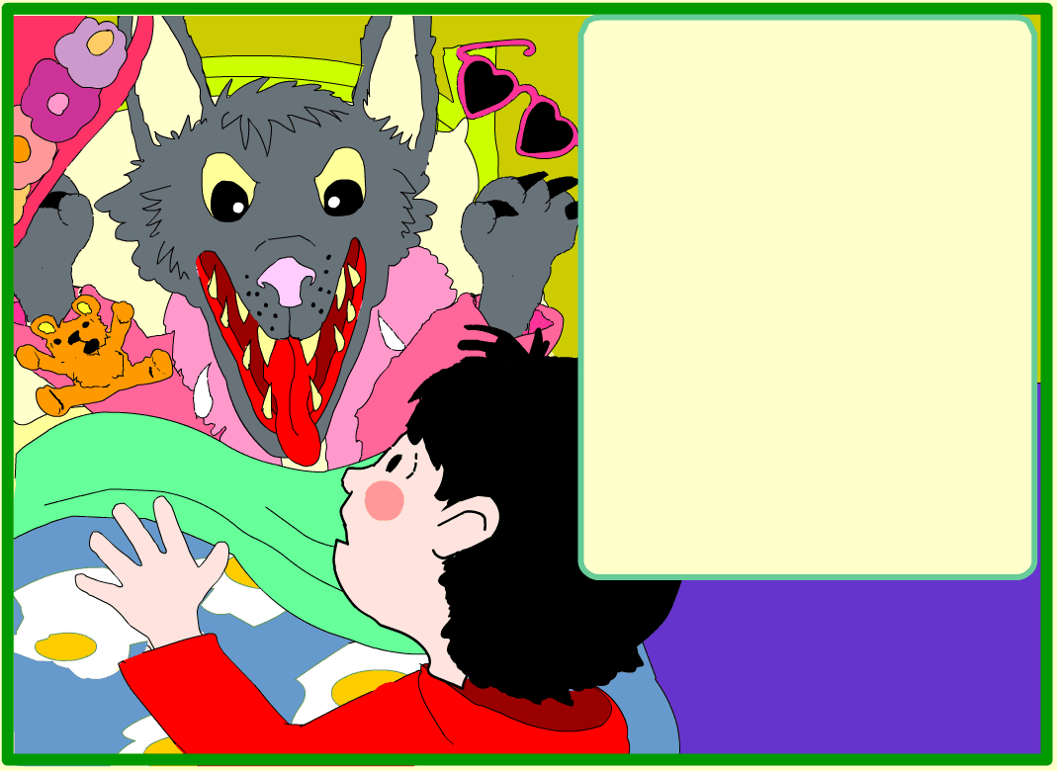
Little Red looked at the wolf's pointed, sharp teeth and said, "Gran, what big teeth you have!"

"All the better to EAT you with my dear," roared the wolf.

He jumped out of the bed!

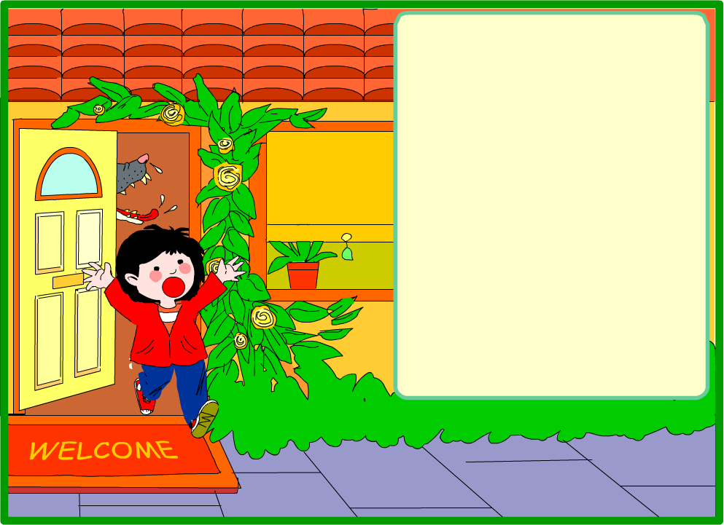
HELP!

Little Red was scared but acted quickly.

She ran outside as fast as she could and shouted for help at the top of her voice.

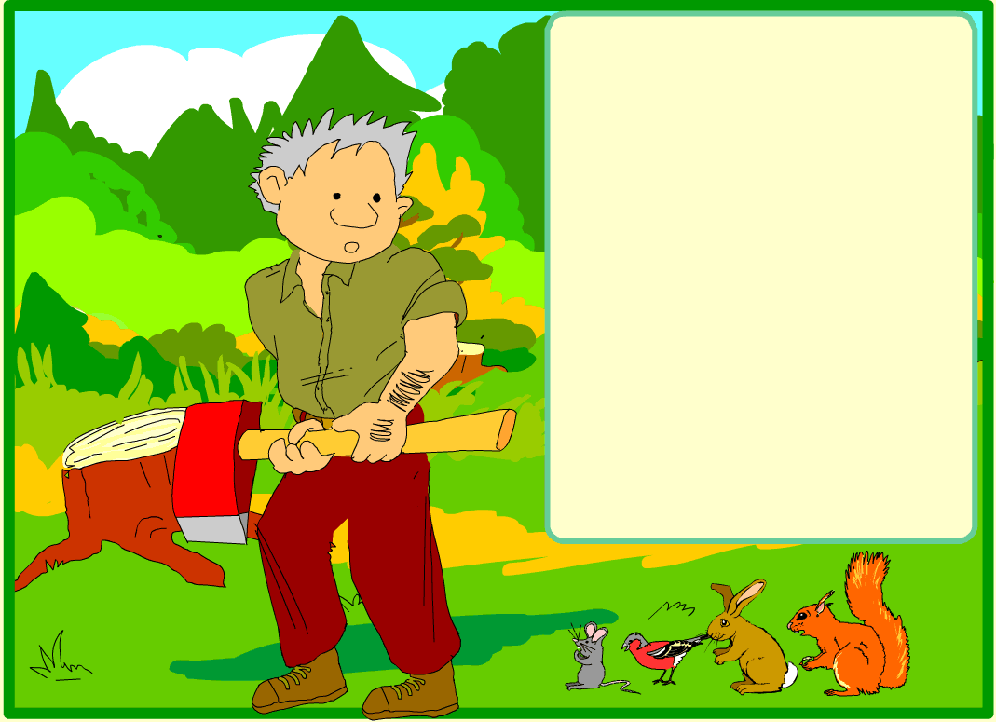

A woodcutter called Jack was working nearby.

He heard her shout.

He grabbed his axe and ran as fast as he could to Gran's cottage.

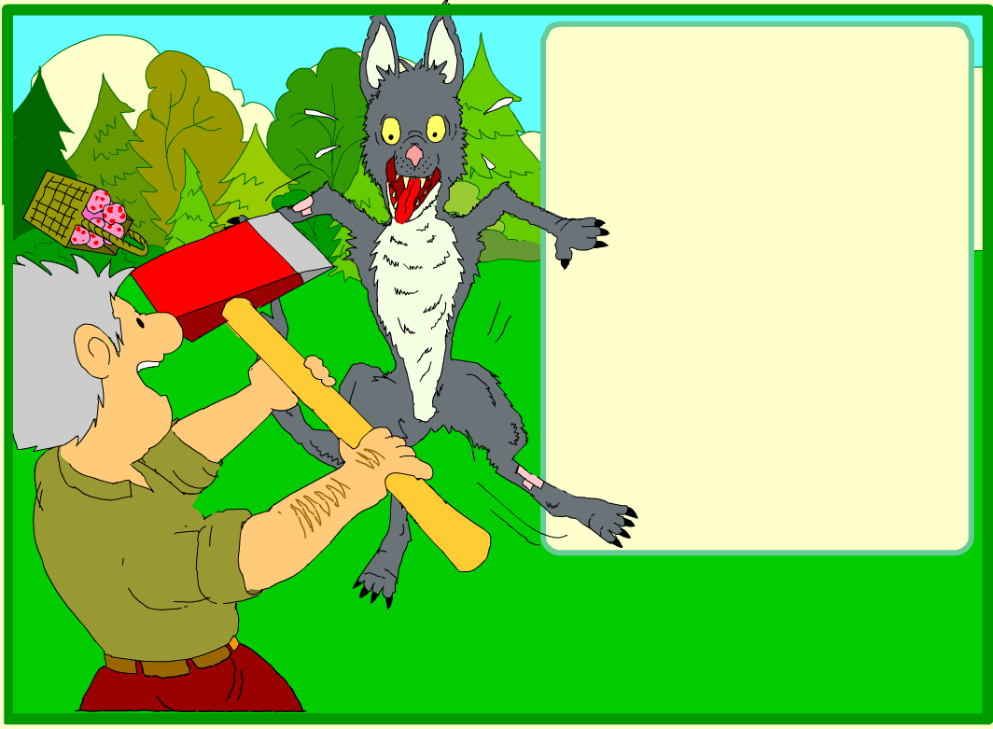
The woodcutter ran up to the wolf, waving his axe. "I'll chop you up!" he shouted.

The wolf was very scared. He dropped the cakes and ran away as fast as he could.

He didn't stop running for a long time.

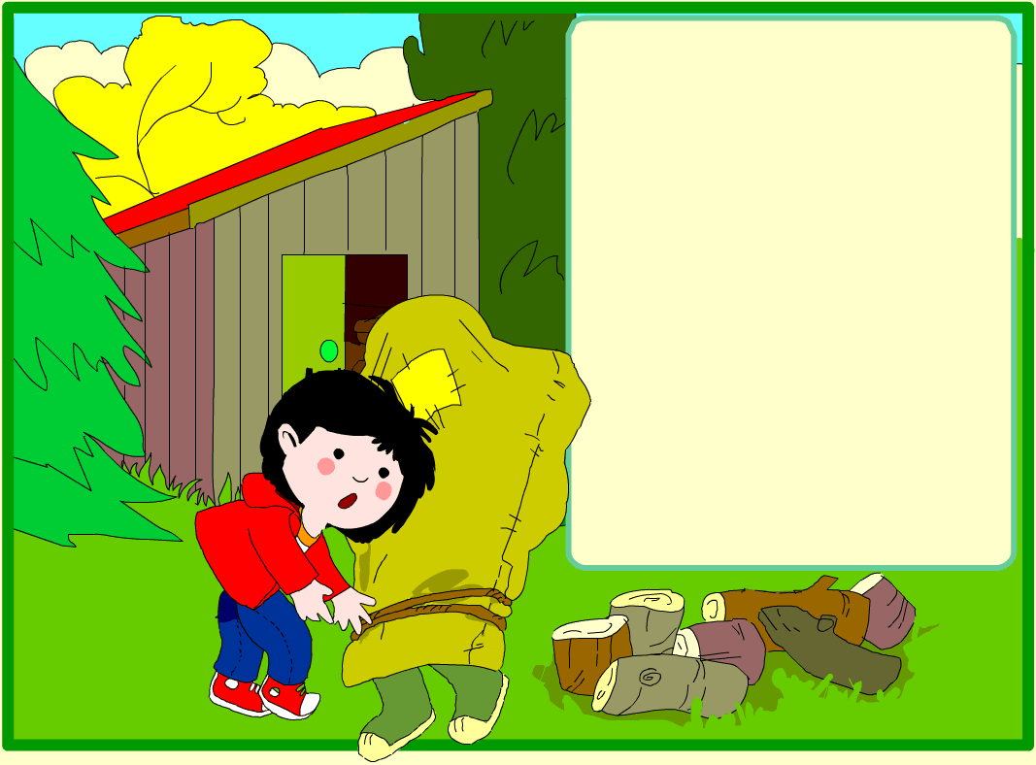

Little Red heard Gran shouting from the shed and ran to free her.

Gran was very angry about what the wolf had done.

She said she would tell everyone to watch out for him.

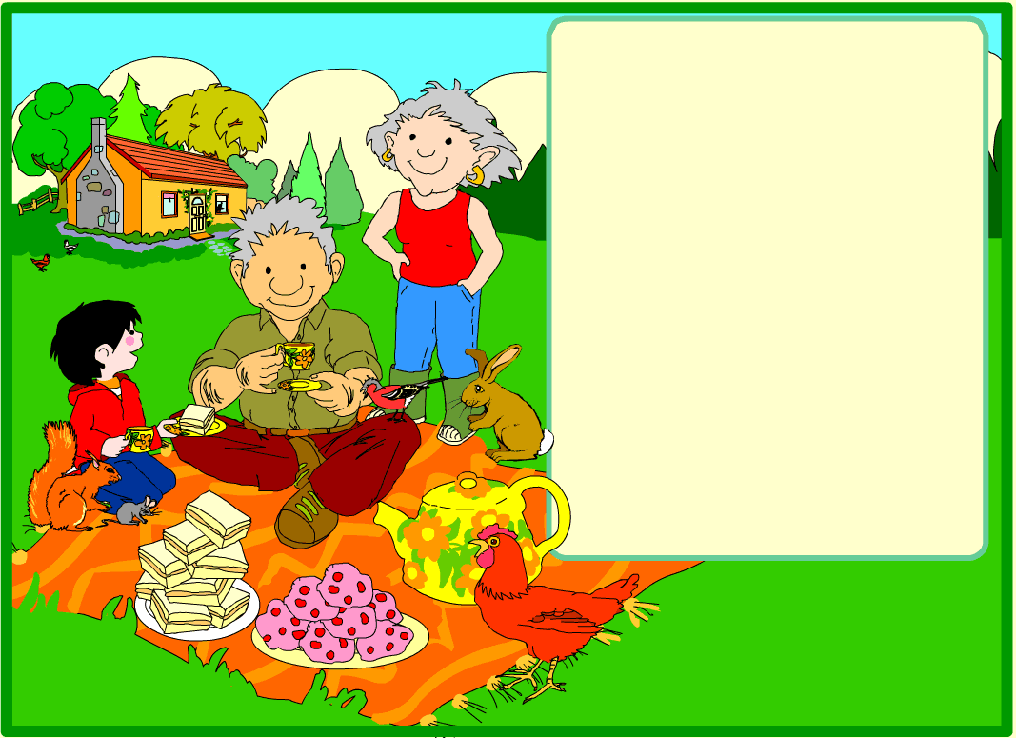
Gran asked the woodcutter to stay for tea. She said he was a hero.

They had banana sandwiches, ate all the cakes and drank lots of tea.

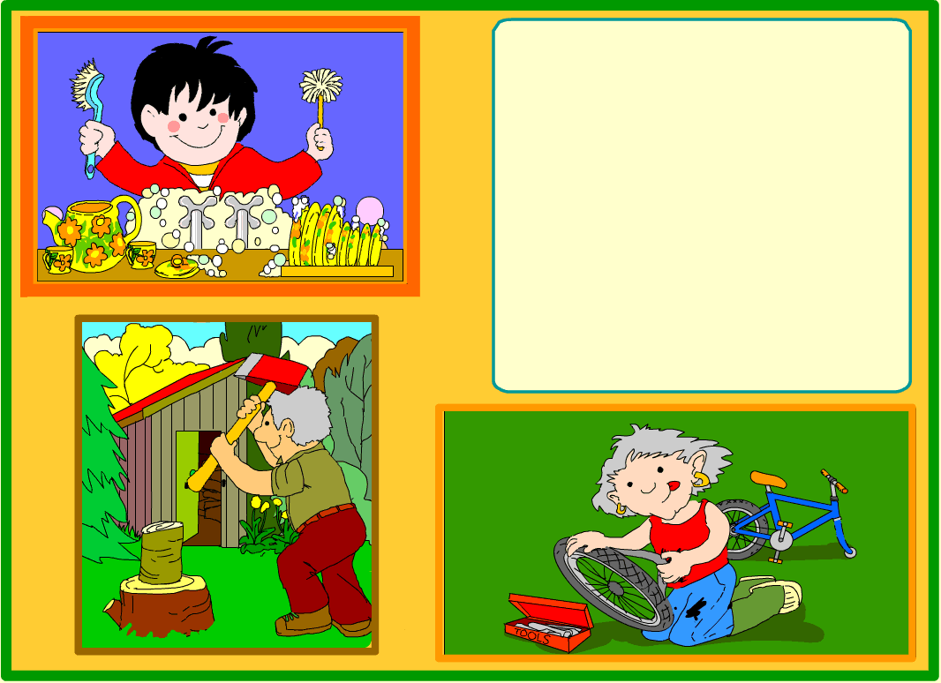
Little Red washed the dishes.

Jack cut Gran's wood.

Gran mended Little Red's tyre.

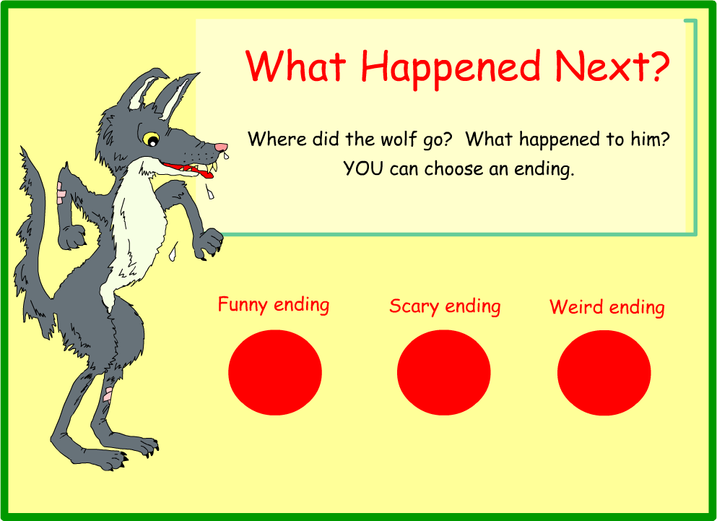
Turn
one
page
Turn
two
pages
Turn
three
pages

tourne deux pages
tournetrois pages

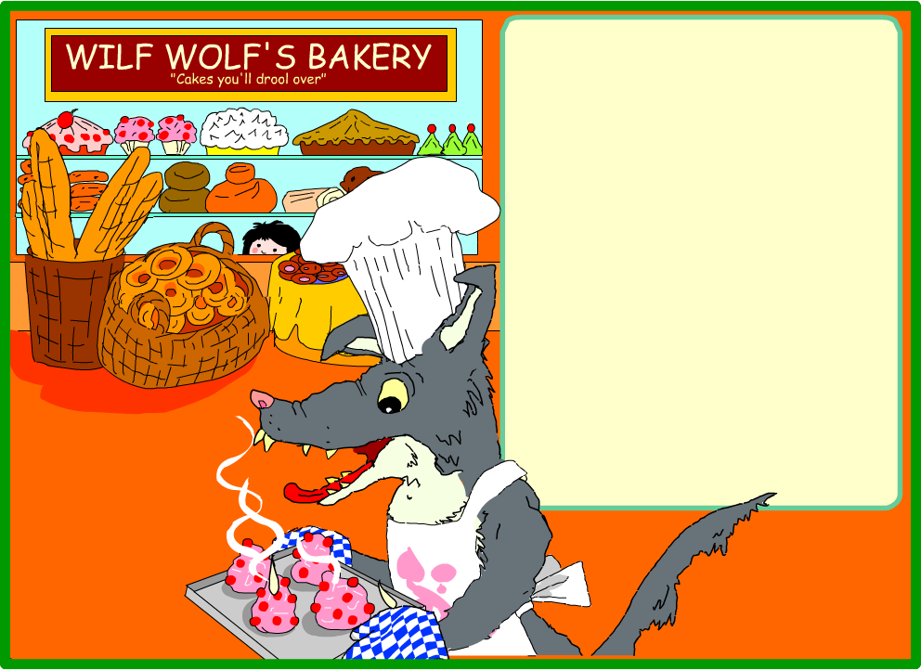
The wolf ran for a long time.

He thought about the cakes.

He decided to become a baker and make his own cakes.

And he was sure they tasted better than little girls!

The End?

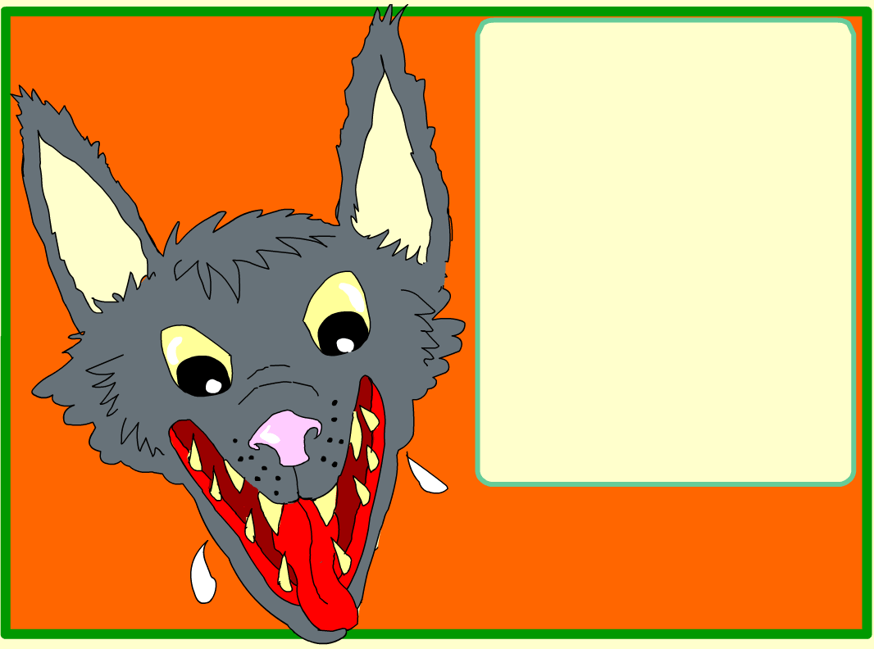

YOU!

The End

The wolf kept on running.

He ran far away and when he stopped, he was standing right behind............

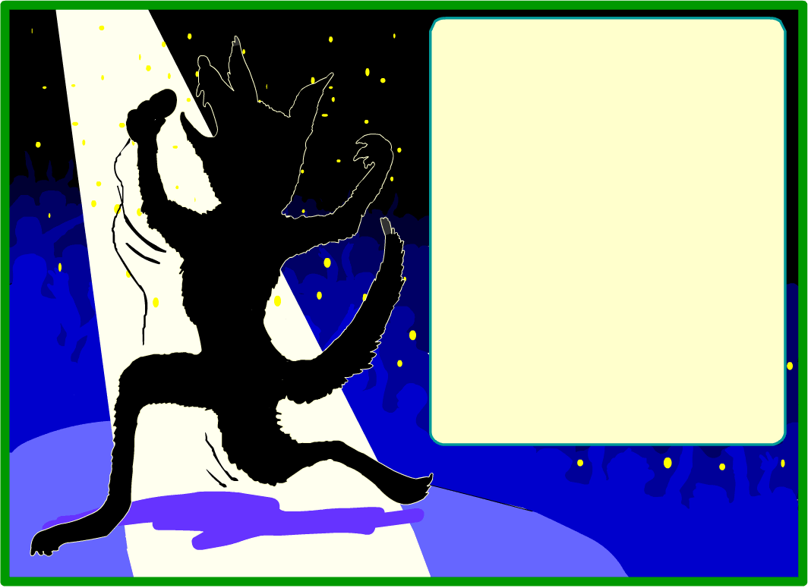
While the wolf ran, he began to think of a song. He called it, "Hey There Little Red Riding Hood".

It became a number one hit!
The wolf was famous. He never thought about eating children anymore. I think he just ate burgers.

The End

While the wolf ran, he began to think of a song. He called it, "Hey There Little Red Riding Hood".

It became a number one hit!
The wolf was famous. He never thought about eating children anymore. I think he just ate burgers.

The End

